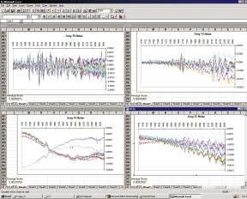
Grey Standards J. Near Infrared Spectrosc. 6, A145-A148 (1998)
Figure 2. Plot of noise spectra from GS2-5 for instrument A.
(Top left, GS5; top right, GS3; lower left, GS4; lower right, GS2)

Grey standards (GS) were polished metal plates painted white (GS1 average Log1/R 0.22), light grey (GS2, 0.69), mid grey, (GS3 0.91), dark grey, (GS4 1.05) and black, (GS5 1.7).
The spectra in Figure 2 are noise plots on NIRS 6500 by normal method.

